**How To Create a Image and store in Shared Image Gallery (Server 2019)**

1. **Create Base Server Machine for Image**
2. In azure portal go to “Create a Resource” and type in “Windows Server” in the search
3. Select “Windows Server”

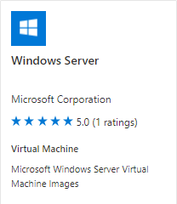

1. Select the Proper Build

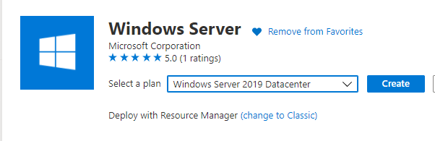

1. Fill out the form sections accordingly

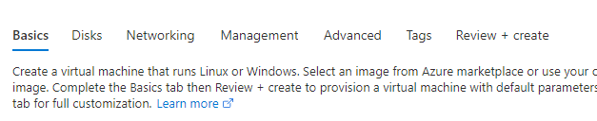

1. When the build is finished log into the VM.
2. Open Powershell ISE as administrator and copy and paste the following code:

&{$C = "IsInstalled=0 and IsHidden=0"

$S = New-Object -ComObject Microsoft.Update.Searcher

$Sr = $S.Search($c).Updates

$Ss = New-Object -ComObject Microsoft.Update.Session

$Dl = $Ss.CreateUpdateDownloader()

$Dl.Updates = $Sr

$Dl.Download()

$Inst = New-Object -ComObject Microsoft.Update.Installer

$Inst.Updates = $Sr

$R = $Inst.Install()

}

start-sleep -seconds 5

mkdir c:\scripts

mkdir c:\temp

mkdir c:\temp\uploads

$source=”azure storage\uploads.zip"

$destination="c:\temp\uploads.zip"

start-bitstransfer -source $source -destination $destination

Expand-Archive -path "C:\temp\uploads.zip" -DestinationPath "c:\temp\uploads"

start-sleep -seconds 5

move "c:\temp\uploads\uploads\aspnetcore-runtime-3.1.11-win-x86.exe" C:\temp

move "c:\temp\uploads\uploads\aspnetcore-runtime-5.0.2-win-x64.exe" C:\temp

move "c:\temp\uploads\uploads\ndp48-x86-x64-allos-enu.exe" C:\temp

move "c:\temp\uploads\uploads\MicrosoftEdgeEnterpriseX64.msi" C:\temp

start-sleep -seconds 5

cd "c:\temp"

.\ndp48-x86-x64-allos-enu.exe /q /norestart

start-sleep -seconds 15

do{

$process=get-process|where-object {$_.name -like "*ndp48-x86-x64-allos-enu.exe*"}

}

until ($process =eq $null)

.\aspnetcore-runtime-3.1.11-win-x64.exe /q /no restart

start-sleep -seconds 15

do{

$process1=get-process|where-object {$_.name -like "*aspnetcore-runtime-3.1.11-win-x64*"}

}

until ($process1 =eq $null)

.\aspnetcore-runtime-5.0.2-win-x64.exe /q /no restart

start-sleep -seconds 15

do{

$process2=get-process|where-object {$_.name -like "*aspnetcore-runtime-5.0.2-win-x64.exe*"}

}

until ($process2 =eq $null)

msiexec.exe /i "MicrosoftEdgeEnterpriseX64.msi" /qn

start-sleep -seconds 15

do{

$process3=get-process|where-object {$_.name -like "*msiexec*"}

}

until ($process3 =eq $null)

dism / online / Disable-Feature / FeatureName: Internet-Explorer-Optional-amd64 /norestart

mkdir "C:\Users\Default\Desktop\tools"

robocopy /s /e /mir "C:\temp\uploads\uploads\tools" "C:\Users\Default\Desktop\tools"

mkdir "C:\Program Files\WindowsPowerShell\Modules\netcease"

robocopy /s /e /mir "C:\temp\uploads\uploads\NetCease" "C:\Program Files\WindowsPowerShell\Modules\netcease"

import-module netcease

Set-NetSessionEnumPermission -Verbose -Confirm:$false

#enable TLS

REG ADD "HKEY_LOCAL_MACHINE\SOFTWARE\Microsoft\Windows\CurrentVersion\Internet Settings\WinHttp" /v DefaultSecureProtocols /t REG_DWORD /d 0xAA0

REG ADD "HKEY_LOCAL_MACHINE\SOFTWARE\Wow6432Node\Microsoft\Windows\CurrentVersion\Internet Settings\WinHttpr" /v DefaultSecureProtocols /t REG_DWORD /d 0xAA0

REG ADD "HKEY_LOCAL_MACHINE\SYSTEM\CurrentControlSet\Control\SecurityProviders\SCHANNEL\Protocols\TLS 1.2"

REG ADD "HKEY_LOCAL_MACHINE\SYSTEM\CurrentControlSet\Control\SecurityProviders\SCHANNEL\Protocols\TLS 1.2\Client"

REG ADD "HKEY_LOCAL_MACHINE\SYSTEM\CurrentControlSet\Control\SecurityProviders\SCHANNEL\Protocols\TLS 1.2\Client" /v DisabledByDefault /t REG_DWORD /d 00000000

REG ADD "HKEY_LOCAL_MACHINE\SYSTEM\CurrentControlSet\Control\SecurityProviders\SCHANNEL\Protocols\TLS 1.2\Client" /v Enabled /t REG_DWORD /d 00000001

REG ADD "HKEY_LOCAL_MACHINE\SYSTEM\CurrentControlSet\Control\SecurityProviders\SCHANNEL\Protocols\TLS 1.2\Server"

REG ADD "HKEY_LOCAL_MACHINE\SYSTEM\CurrentControlSet\Control\SecurityProviders\SCHANNEL\Protocols\TLS 1.2\Server" /v DisabledByDefault /t REG_DWORD /d 00000000

REG ADD "HKEY_LOCAL_MACHINE\SYSTEM\CurrentControlSet\Control\SecurityProviders\SCHANNEL\Protocols\TLS 1.2\Server" /v Enabled /t REG_DWORD /d 00000001

REG ADD "HKEY_LOCAL_MACHINE\SOFTWARE\Microsoft\.NETFramework\v2.0.50727" /v SystemDefaultTlsVersions /t REG_DWORD /d 00000001

REG ADD "HKEY_LOCAL_MACHINE\SOFTWARE\Microsoft\.NETFramework\v2.0.50727" /v SchUseStrongCrypto /t REG_DWORD /d 00000001

REG ADD "HKEY_LOCAL_MACHINE\SOFTWARE\Microsoft\.NETFramework\v4.0.30319]" /v SystemDefaultTlsVersions /t REG_DWORD /d 00000001

REG ADD "HKEY_LOCAL_MACHINE\SOFTWARE\Microsoft\.NETFramework\v4.0.30319]" /v SchUseStrongCrypto /t REG_DWORD /d 00000001

REG ADD "HKEY_LOCAL_MACHINE\SOFTWARE\Wow6432Node\Microsoft\.NETFramework\v2.0.50727" /v SystemDefaultTlsVersions /t REG_DWORD /d 00000001

REG ADD "HKEY_LOCAL_MACHINE\SOFTWARE\Wow6432Node\Microsoft\.NETFramework\v2.0.50727" /v SchUseStrongCrypto /t REG_DWORD /d 00000001

REG ADD "HKEY_LOCAL_MACHINE\SOFTWARE\WOW6432Node\Microsoft\.NETFramework\v4.0.30319" /v SystemDefaultTlsVersions /t REG_DWORD /d 00000001

REG ADD "HKEY_LOCAL_MACHINE\SOFTWARE\WOW6432Node\Microsoft\.NETFramework\v4.0.30319" /v SchUseStrongCrypto /t REG_DWORD /d 00000001

reg add HKEY_LOCAL_MACHINE\SYSTEM\CurrentControlSet\Services\Tcpip6\Parameters /v DisabledComponents /t REG_DWORD /d 0x20 /f

1. Run the patch section until there are no more patches to install and do all necessary reboots.

**B. Sysprep the VM**

1. Run c:\windows\system32\sysprep\sysprep.exe

-Select Generalize and Shutdown as the option.

**C. Capture VM**

1. In azure portal select the vm click the Capture button and fillout the necessary information. Make sure to fill out the version number

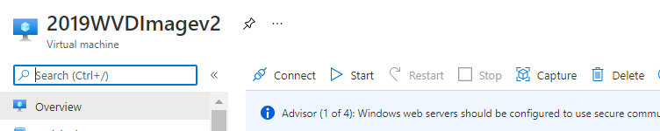

**D. Create Shared Image Gallery when prompted or Add it to existing one**